ANNEX 2.6

Exercise Artemis
Participant briefing
10 September 2013

ANNEX 2.6 Exercise Artemis
Participant briefing
10 September 2013
TABLE OF CONTENTS

Contents
Introduction 3
background 3
What is Exercise Artemis? 3
What is the exercise scenario? 3
When and where will the exercise take place and when do I need to be there? 3
Who is taking part in the exercise? 4
What are the aim and objectives? 5
HOW THE EXERCISE WILL WORK AND WHAT I NEED TO DO TO PARTICIPATE 5
What are the implications for me? 5
What is a command post exercise? 5
What background sources will be needed? 5
What are the exercise assumptions? 5
What are the exercise artificialities? 6
COMMUNICATIONS 6
HOW TO RECEIVE AND SEND INFORMATION 7
What will be simulated during the exercise? 8
What safety and security issues should I be aware of? 8
EXERCISE EVALUATION 8
EXERCISE EVALUATION METHODOLOGY 8
How will the exercise be evaluated? 9
POST EXERCISE REPORT 9
Food and refreshments 9
APPENDIX A - EXERCISE SCHEDULE 10
APPENDIX B : EXERCISE LOCATION 11
APPENDIX C - EXERCISE STAFF AND PLAYERS 12
APPENDIX D – Exercise structure 13
APPENDIX E – EXERCISE DIRECTORY 15
APPENDIX F: KEY REFERENCES 17

Introduction
Thank you for agreeing to take part in Exercise Artemis. This briefing pack contains information about how the exercise will be conducted. Should you require further information please contact Camilla Croneld, Emergency Operations Group Leader.

background
This exercise is a European Centre for Disease Prevention and Control (ECDC) initiative, designed to provide an opportunity to inform ECDC staff on the response to a Public Health Emergency (PHE), focused around an outbreak of a communicable disease.
The exercise is being conducted by Public Health England (Emergency Response Department) of the United Kingdom under a framework service contract to ECDC. Exercise Artemis will take place at ECDC on 10 September 2013, as a Command Post Exercise (CPX), and will last approximately 8 hours.

What is Exercise Artemis?
Exercise Artemis is a Command Post exercise. The exercise has been designed by Public Health England working with a team from ECDC to assist in the familiarisation of ECDC staff in their response to a PHE.

The aim of the exercise is to provide ECDC staff with the opportunity to use and implement the PHE Operational Plan and to test supporting documents, tools and templates.

This will be achieved by giving participants a scenario which they will have to respond to using the plans and protocols that ECDC has in place. This exercise also builds on the lessons learned during the simulation Exercise Beavi (15-16 May 2012) and offers an in-depth opportunity for ECDC staff to rehearse their roles and responsibilities in order to be better prepared for any potential activation of the PHE management system.

What is the exercise scenario?
The scenario is set for 10 September 2013 and exercise documentation will show this date. The scenario provides a fictional narrative for ECDC to respond to. The scenario will not be revealed to players prior to the exercise.

When and where will the exercise take place and when do I need to be there?
A briefing for all participants will be held at 16:00 on 9 September 2013 in the Boardroom at ECDC.
The exercise will take place on 10 September 2013 during normal working hours (08:00 – 17:00). The Exercise Schedule is at Appendix A.

The following rooms will be used during the exercise:

Function | Location
Exercise Control | Function Room 2, EOC
Audio-conference | Room 254
Participant Briefing (9 September)  Webstreaming  Hot Debrief | Boardroom
Exercise Participation | EOC  Communications
Refreshments | Room 435

The Exercise Control staff, including Pseudo Media will be based in Exercise Control in Function Room 2 of the EOC. If required, an audio-conference facility will be available in Room 254 and can be booked via Exercise Control. The Boardroom will be used for all presentations, web streaming and the hot debrief.

Lunch and refreshments will be served in room 435. A floor plan of the rooms used for the exercise is at Appendix B.

Who is taking part in the exercise?
The targeted ECDC personnel for this exercise are those who will be assigned to a specific functional group before, during and after a PHE.

- PHE management team, observers, advisors
- PHE group leaders, evaluator, assistant
- PHE technical group
- PHE Communication
- PHE Administrative support
- PHE EOC

Exercise Control: Staff from Public Health England and ECDC will control and evaluate the exercise. If you have any questions about your role in the exercise you should speak with Exercise Control in the first instance. A list of the staff involved in the planning and execution of the exercise and of those taking part is at Appendix C.

What are the aim and objectives?
The aim of the exercise is to provide ECDC staff with the opportunity to use and implement the PHE Operational Plan and to test supporting documents, tools and templates.

Increased knowledge of the PHE concept, Operation Plan, Intranet platform and the supporting documentation will ensure a successful internal management of a PHE. The exercise should contribute to the individual learning of all participants.

The objectives of this exercise are to:
- To increase the knowledge of the PHE concept , procedures and command structure
- To familiarise ECDC staff with their roles and responsibilities during a PHE
- To identify any gaps in PHE response arrangements

HOW THE EXERCISE WILL WORK AND WHAT I NEED TO DO TO PARTICIPATE

What are the implications for me?
When you are playing you should assume that you cannot do your normal job, therefore please make the appropriate arrangements for cover.

What is a command post exercise?
In a command post exercise, players respond as they would to a real emergency, in accordance with their emergency plans. So, you may work from your own office, control rooms or emergency operations centre (as your plan dictates). You should follow the plans you have, as you would do during a real PHE. However, because this is an exercise there will be times when you should not follow your plans exactly (for example, you should not contact external agencies that are not involved in the exercise; these will be represented by Exercise Control staff). You will be told when this is the case. See the paragraph on Exercise Artificialities below.

What background sources will be needed?
Players should make use of their normal response plan, SOPS, tools and templates. Any further clarity for response will be provided by the internal exercise lead for ECDC.

What are the exercise assumptions?
It is assumed that exercise players will respond in accordance with existing plans, procedures, and policies. In the absence of applicable plans, procedures, or policies, players will be expected to apply individual and/or team initiative to satisfy response requirements.

What are the exercise artificialities?
It is recognised that certain artificialities and constraints are unavoidable in an exercise of this nature.

Exercise time: This exercise takes place in real time; however, some time scales (e.g. microbiological results) may have been shortened to facilitate the exercise. Players should recognise and work within these limitations in order to accomplish the exercise objectives.

Exercise date: The date used in the scenario (10 September 2013) is for illustrative purposes only and does not reflect the actual activity or events taking place in real life.

External agencies: There will be times during the exercise when your plans will dictate that you should contact colleagues in agencies outside of ECDC (for example DG SANCO, WHO or a Member State). If this is the case, you should not contact those organisations, but instead contact Exercise Control who will simulate those roles. A directory of the phone numbers and email addresses you should use is attached at Appendix D.

COMMUNICATIONS
Players will have all the communications means that they would usually use available to them during the exercise with the following exceptions:
- EWRS and similar systems – will be replicated by sending an email which is marked to the effect that the information contained in the email would have been sent using an alternative system.
- Media (including social-media) – players from ECDC’s communications team should not contact the real media or use real social-media tools during the exercise. Social media feeds (such as Twitter) and newspaper reports will be replicated by email injects.
- Communications between control staff, evaluators and Exercise Control will be by separate phone and email.

Communication tools: For advice on how you should communicate with other players and Exercise Control see below:

HOW TO RECEIVE AND SEND INFORMATION
Information from Control Staff: You will receive information from the exercise staff in the following ways:
- Injects: Injects are information about the scenario that you will need to react to. You will receive injects either by email, telephone call, fax, on a piece of paper, people acting out a role, or by one of the control staff telling you what has happened.
- Communication systems such as EWRS: You will not receive injects using EWRS or any similar system. Information that would normally come to you using one of these systems will be sent on an email.
- Briefings: This is information about how the exercise is running or will be run (for example this document). Briefings will be delivered verbally or in a document.
- Information to colleagues and exercise staff: You should use all of the communications methods you would usually use to respond to the scenario as though it was a real PHE. However, in order to allow the exercise to run properly and to be evaluated effectively please be aware of the following:
  - External communications: Please do not communicate directly with any organisation outside of ECDC (even if this is what you would do in reality). If you need to communicate with an organisation outside of ECDC please refer this to a member of the exercise staff who will assist you.
  - Posting on EWRS. If there is information you would normally send out of ECDC using EWRS, you should write that information on an email and send it to Exercise Control, marking the email for the attention of EWRS.
- Emails: Copy all emails you send to the Exercise Control email accounts. This will allow evaluators to follow your actions and deliver a comprehensive evaluation. The email address for Exercise Control is in the Exercise Directory at Appendix D.
All exercise communications (oral and written) must be preceded by the statement:
‘Exercise-Exercise-Exercise Artemis’

There will be no live play and there will be no real media participation beyond the confines of the ECDC during the exercise.

What will be simulated during the exercise?
Exercise Control will play the role of any organisation or function external to ECDC. Contact Exercise Control instead of contacting any external organisation or function.

What safety and security issues should I be aware of?
Safety and security during the exercise is the responsibility of ECDC. In the case of a real emergency occurring, the exercise will be terminated by the Exercise Director.

EXERCISE EVALUATION

EXERCISE EVALUATION METHODOLOGY
-
Hot
Debrief
Participants
observations / comments
Control Staff/ Evaluators observations / comments
Hot Debrief
Outputs
Evaluator report
Cold Debrief
Draft
report

The exercise evaluation methodology will be as follows:
- All players will record any issues or learning points in evaluation workbooks provided and will also feedback during the hot debrief session at the end of the day
- Public Health England evaluator and the ECDC evaluators will record issues and learning points and critically analyse the performance of the players and feedback to the Exercise Manager through a formal report by 18 September 2013.
- Participants will complete a feedback form and will participate in the hot debrief on the day of the exercise
- The ECDC Evaluator will submit his report to the Exercise Manager by 18 September 2013 and will also feedback at the post-exercise evaluation workshop
- All participants should take part in the post-exercise evaluation workshop on 23 September 2013 to be held at ECDC (Cold Debrief)
- A draft final report will be produced for consultation with the planning group and stakeholders within 4 weeks of the exercise and a full report for all participants by week commencing 21 October 2013.
- A report based on the findings from the evaluation of the exercise will be produced by Public Health England and submitted to ECDC.

How will the exercise be evaluated?
- During the day, Evaluators will observe, record, comment and evaluate any issues or learning points regarding PHE response activities. If there are any issues or concerns about the processes and systems being used, players may discuss these with the exercise control staff during the exercise. These issues will be noted and will be used to inform valuable feedback.
- Participants will take part in a debrief immediately at the end of the exercise (ENDEX). This debrief will be facilitated by exercise staff. In addition, players will have the opportunity to record their actions and decisions during the day in a player evaluation workbook (Ser 3.2).
- Evaluators will be provided with an evaluation report template (Ser 3.1) which they should complete and submit to the exercise manager by 18 September 2013 at the latest.
- The notes from the Evaluator attached to ECDC’s Strategic Management Team should also be submitted to the exercise manager by 18 September 2013.
- Evaluators and control staff will take part in a debrief immediately following ENDEX. This debrief will be conducted by the exercise manager.

POST EXERCISE REPORT
The post exercise report will be completed in draft form for the post exercise workshop on 23 September 2013. During this meeting, the EPG will be asked to review the preliminary report in detail and provide comments. The final post exercise report will be disseminated after the post exercise workshop.
The post exercise report will include:
- a record of major observations
- a record of lessons identified
- recommendations for improvements to the PHE-SOPs and supporting documents and tools
- recommendations for future training and exercises

Food and refreshments
Food and refreshments will be provided for exercise participants.

APPENDIX A - EXERCISE SCHEDULE
Date and Time | Activity and location
9 September – 16:00 | Briefing for exercise players (Boardroom)
 | (possible background injects/alert)
10 September 2013 | CONDUCT OF THE EXERCISE
08:00 | EXERCISE STARTS
Players work within their functional groups in accordance with PHE OP, SOPs and Job Action Sheets.
Daily schedule of events during alert and acute stage of PHE will be followed where possible.
12:15 | Working lunch available
16:30 | EXERCISES ENDS
16:30 – 17:00 | Hot Debrief for all exercise participants (Boardroom)  Closing comments (ECDC Director)
23 September 2013 | POST-EXERCISE EVALUATION WORKSHOP
09:30 | Feedback on the exercise  Group summary feedback  Evaluators debrief  Next Steps
10 October 2013 | Draft post exercise report
w/c 21 October 2013 | Post Exercise Report to ECDC

APPENDIX B : EXERCISE LOCATION

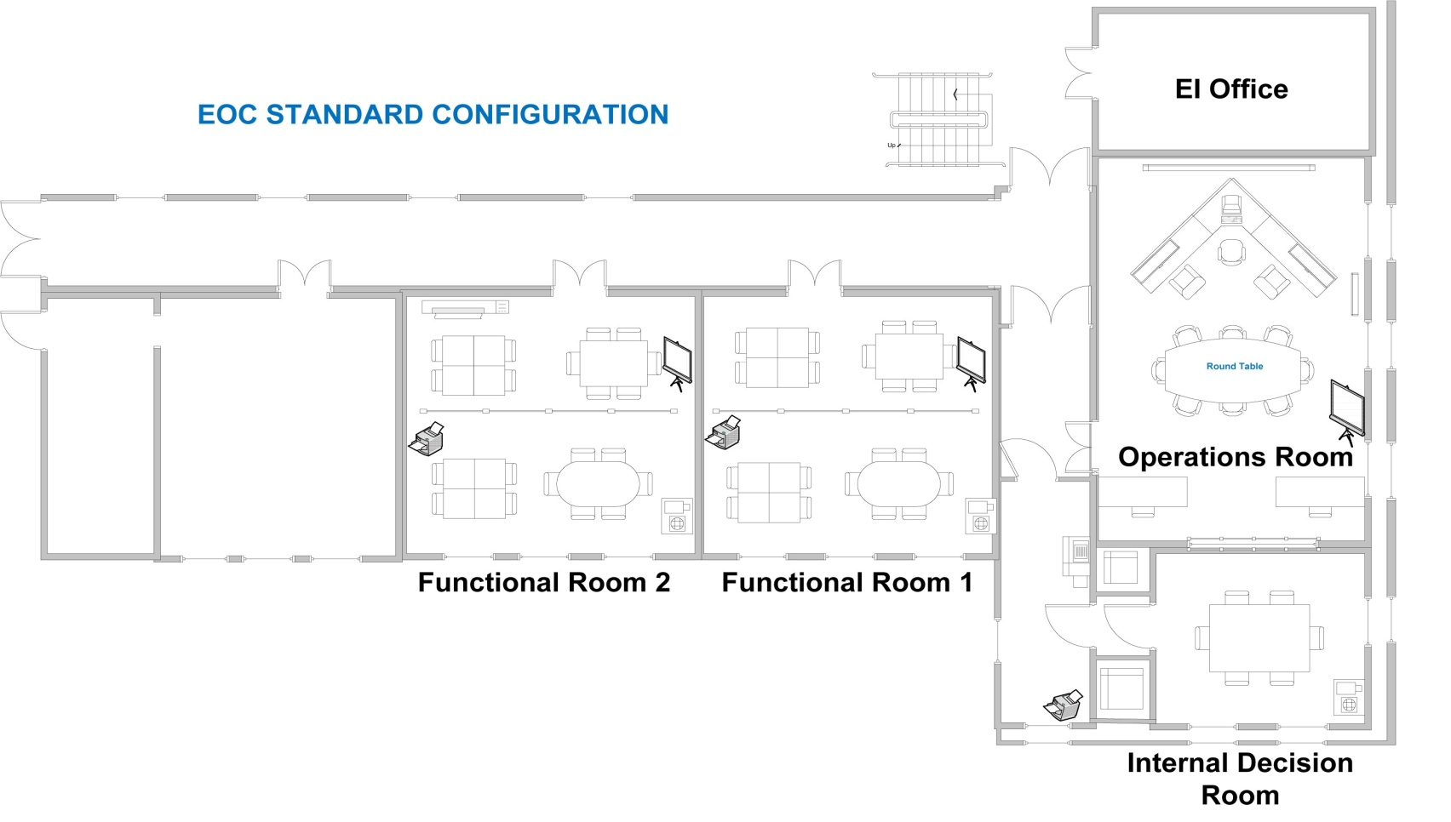

APPENDIX C - EXERCISE STAFF AND PLAYERS

EXERCISE STAFF

ECDC |  | Public Health England
Role | Name | Role | Name
ECDC Subject Matter Expert |  | Exercise Director
ECDC Subject Matter Expert |  | Exercise Manager
ECDC IT |  | Exercise Coordinator
ECDC Evaluator |  | Pseudo Media
ECDC |  | Evaluator
 |  | Evaluator

EXERCISE PLAYERS
A proposed list of participating organisational functions for this exercise is given below:
Director
Deputy of the Director
Chief Scientist
Head of SRS
Evaluator
Internal Communication
Business Continuity
PHE Manager
PHE Manager Secretary
PHE Manager Assistant
Strategic analyst
Technical Group
Epidemic Intelligence/Surveillance
Assessment/Response
Microbiology
EOC Group
PHE Logger
EOC Technology
Logistics and Outbreak
ICT Support
Communications Group
Media Coordinator
Press/Media Officer
Web/Social Media Coordinator
Web/Social Media Editor
Administrative Group
Human Resources
Facility/Logistics
Security
Missions and Meetings
Finance

APPENDIX D – Exercise structure

The structure for the exercise is as shown below. The exercise will be controlled from ECDC.

Evaluation
Pseudo Media
Exercise Control

APPENDIX E – EXERCISE DIRECTORY

You should only use the contact details provided in this directory. If you need to call any other organisation not included here, you should check first with Exercise Control.

YOU MUST START ALL EXERCISE COMMUNICATIONS (WRITTEN AND ORAL) WITH:
“EXERCISE – EXERCISE – EXERCISE ARTEMIS”

EXERCISE CONTROL

EMAIL | TELEPHONE | ROLE
Artemis.excon1@ecdc.europa.eu | Ext: xxxx  External xxxx  Ext: xxxx  External: xxxx | Use these contact details to:  -Respond to injects  -To copy Exercise Control on any correspondence with other members of ECDC  -To contact any organisation external to ECDC, for example: EU Member States and DG SANCO (Played by Exercise Control staff)
Artemis.communications@ecdc.europa.eu | Ext: xxxx  External: xxxx | Use these contact details to:  -Speak to the communications department of any organisation external to ECDC and the media (Played by Pseudo Media in Exercise Control)

To contact colleagues within ECDC you should use the ECDC Directory. A list of generic email accounts are listed here for your convenience.

PARTICIPANTS
FUNCTION GROUP | EMAIL
Administrative support group leader

Assessment

Business continuity correspondent

Communication group leader

Director

EI Duty Officer
EOC group leader

EOC Internal communication

EOC logger

EOC logistics and outbreak

EOC technology

Epidemic intelligence/Surveillance

Facility and Logistic
Human Resources

Internal communication coordinator

ICT Support

PHE Manager

PHE Manager assistant
Response

Security
Technical group leader

Use the email accounts and telephone numbers listed in this directory.

Remember to copy Artemis.excon1@ecdc.europa.eu in your correspondence with other participants and tell your evaluator if you make phone calls.

APPENDIX F: KEY REFERENCES
ECDC Public Health Emergency Operation Plan (V 7.0)
ECDC SOPs for PHE
24/7 EI Duties SOP
PHE Activation SOP
PHE Appointment SOP
Round Table SOP
PHE Staff Assignment and Roster SOP
PHE Communication SOP
PHE Evaluation SOP
PHE Information Flow SOP
PHE Upgrading SOP
PHE Downgrading SOP
PHE Log SOP
PHE Multiple SOP
PHE EOC Activation SOP
PHE Sitrep SOP
PHE EOC Deactivation SOP
PHE RAO SOP
ECDC Guide to Missions and Meetings
Stress Management & Wellbeing SOP

PHE Job Action Sheets, Checklists & Templates

