Annex 2.2
ECDC Simulation Exercise Artemis
SCOPING DOCUMENT

Purpose of document

The purpose of this document is to establish the project approach and scope for the exercise. Once reviewed and signed off this document will form the definitive description of the exercise scope, approach and governance.

Background

This exercise is a European Centre for Disease Prevention and Control (ECDC) initiative, designed to provide an opportunity to evaluate and develop preparedness for public health events, focused around an outbreak of infectious disease.
The exercise is being conducted by Public Health England of the United Kingdom under a framework service contract to ECDC. Exercise Artemis will take place at ECDC. It will be conducted, on 10 September 2013, as a walk through “learning by practice” exercise Command Post Exercise (CPX), and will last approximately 8 hours.

Context

During 2011-12 the PHE operation plan was revised and SOPs, manuals and an interim PHE internet platform (a new PHE platform is being developed during 2013 by the Internet team) was developed and tested by means of a simulation exercise (Exercise Beavi).
This exercise builds on the lessons learned during the simulation Exercise Beavi (15-16 May 2012) and offers an in-depth internal training opportunity for ECDC staff, through practice, in order to be better prepared for a potential activation of the PHE management system. One of the lessons learned from Exercise Beavi was that there is a need for internal training on the PHE plan, supporting documentation and the new PHE intranet platform. This ‘lesson learned’ was envisaged prior to the simulation exercise but, due to time constraints, no in-depth training was offered to ECDC staff at that time.

A PHE e-tutorial will be available in early 2013; nevertheless, the EOC group is preparing training for ECDC staff, through practice, in order for them to be better prepared for a potential activation of the PHE management system. Well trained and exercised ECDC staff is a major component in ensuring successful managing of a public health crisis by ECDC.

Aim of the Exercise

The Aim of the exercise is to train the ECDC staff to the new PHE structure and to provide them with tools to conduct the expected tasks more effectively.

Enhanced knowledge of the PHE concept, PHE operation plan, Intranet platform and supporting documentation will enable staff to respond to a PHE in a more effective manner. The exercise will also build on the continuous learning of the engaged staff.

Exercise Objectives

The objectives of the exercise are:

To increase the knowledge of the PHE concept, procedures and command structure To train ECDC staff to use the PHE operation plan and supporting documents as well as the PHE intranet.

Exercise Scenario
Participants in the exercise will be given a scenario which they will have to respond to using the plans and protocols that ECDC has in place for PHE management. The scenario will be based on an outbreak of a communicable disease in a Member State(s) that will address the aim and objectives of the exercise, in the context of PHE level 1 and escalation to PHE level 2.

Exercise project scope

  - Out of scope
The following aspects will be outside the scope of this exercise:

There will be no live exercise play There will be no real media participation

Exercise Control will simulate any participation by external agencies or organisations that would normally be involved in the PHE response activities.

  - Assumptions
It is assumed that exercise players will respond in accordance with existing ECDC plans, procedures, and policies. In the absence of applicable plans, procedures, or policies, players will be expected to apply individual and/or team initiative to satisfy response requirements. Players will be briefed on which exercise assumptions are made outside of plans/policies.

Timing and location of exercise

The exercise will be conducted on 10 September 2013 at ECDC in Stockholm, Sweden during normal working hours (08:00 – 18:00). The exercise will take place within ECDC’s EOC and adjacent rooms. Players may also be based at their own workstations/offices if that is what the plan says.

Key References

PHE Operation Plan (Version 7.0) PHE EOC Activation (Final)
PHE Appointment (Final)
PHE Evaluation (Final) PHE Information Flow PHE Log (Final)
PHE Multiple (Final) PHE Sitrep (Final)
PHE Downgrading (Final) PHE EOC Deactivation (Final)
Job Action Sheets and templates

Exercise Planning
  - Exercise Planning Team

The planning team for the exercise will be led by Public Health England, Porton Down. The planning team will comprise the following representatives:

Name | Job title | Organisation
 | Senior Scientific Adviser | Public Health England
 | Exercise Manager | Public Health England
 | Exercise Coordinator | Public Health England
 | Threat Assessment Specialist | ECDC
 | Senior Expert – Epidemic intelligence Group leader Epidemic Intelligence  and Emergency Operations | ECDC
 | Secretary - Surveillance and Response Support Unit (SRS) | ECDC

The planning team is collectively responsible for the planning, design and running of the exercise, including writing the scenario and injects, and will meet regularly as agreed in the exercise schedule.

Exercise schedule

The planning schedule is shown at Appendix A.

Exercise structure

The structure for Exercise ARTEMIS will be based upon the ECDC PHE management structure.

Exercise Design

This exercise will be run as a command post exercise and will be controlled by Exercise Control and through the Facilitation team.

Exercise delivery

Delivery of the exercise material will be via pre-prepared paper and messaging injects, telephone calls and updates. Where possible, use will be made of technology for appropriate injects (email, mock media broadcasts, etc)

Media

  - There will be no external media/communications. Information flow will use internal communications only.

Evaluation

Evaluation of the exercise will be based on participants’ and observers’ feedback as well as reports and observations from Facilitators. Facilitators will record issues and learning points and critically analyse the performance of their respective syndicates and feedback to the exercise manager through a formal report. Participants will participate in a hot debrief on day two of the exercise presenting two - three key points/issues.

Report

Public Health England will produce a draft report to be shared with the exercise planning team. A final report will be delivered to ECDC for their internal distribution.

APPENDIX A: Planning schedule

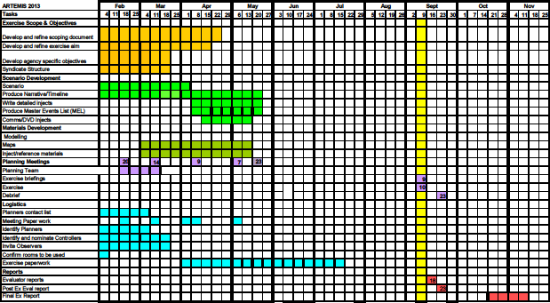

5

