**MODULE 1: HOSPITAL**

INJECT 1.0



**DATE:** 7 May  
**FROM:** Anytown Hospital   
**SUBJECT:** Legionnaires’ disease case reports

**Report from Anytown Hospital**

Please find below details of a cluster of two cases of Legionnaires’ disease at Anytown Hospital. Two patients have tested positive for *Legionella* by urinary antigen test on 6 May and present with symptoms of pneumonia. Sputum samples have been submitted for further microbiological testing, including culture.

They were both exposed to the hospital’s haematology-oncology ward for the whole duration of their incubation period (2-10 days prior to symptom onset). The patients were admitted for treatment for active leukaemia and have received chemotherapy during their admission.

These results may be indicative of a hospital-associated outbreak and we are concerned about the possibility of an ongoing exposure risk for *Legionella* to other patients, visitors and employees.

Due to the patients’ deteriorating condition, patient information is limited at present.

**Patient details:**

|  |  |  |  |  |  |  |
| --- | --- | --- | --- | --- | --- | --- |
| **ID** | **Sex** | **Age** | **Date of admission** | **Clinical status** | **Microbiology results** | **Date of test** |
| 1 | F | 54 | 22/04 | Severe symptoms of pneumonia | UAT positive | 06/05 |
| 2 | M | 78 | 23/04 | Severe symptoms of pneumonia | UAT positive | 06/05 |

**MODULE 1: HOSPITAL**

INJECT 1.1



**DATE:** 7 May  
**FROM:** Anytown Hospital   
**SUBJECT:** New haematology-oncology ward

**Information about the new ward**

Good morning,

Here is some more information about the new haematology-oncology ward at the hospital. Hopefully this might help with the outbreak investigation.

* The Haematology-Oncology ward of Anytown Hospital is a state-of-the-art medical facility and serves as a referral centre for patients throughout the country.
* The hospital is particularly proud that a recent renovation of the existing building has allowed for more patients to be admitted and be treated with newer technology.
* The renovations and construction work were completed earlier this year, with the ward being reopened for patients on 20 February.
* The Haematology-Oncology ward contains 27-single-occupany patient rooms and occupies half a floor of a 9-story building with independent water and ventilation systems. The ward shares a plumbing system with three floors in the building, which house hospital offices and storage units.

Kind regards,

Anytown Hospital Administration

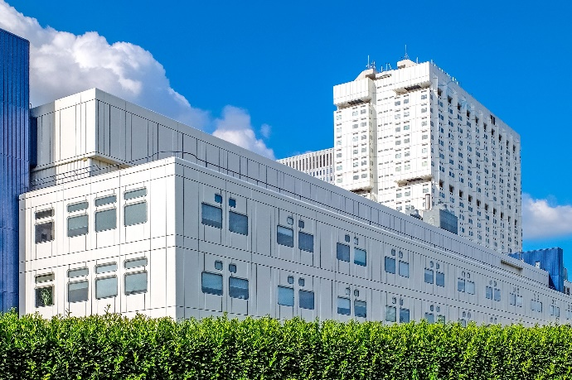

**MODULE 1: HOSPITAL**

INJECTS 1.0 & 1.1

**SESSION 1: QUESTIONS**

1. What is your initial risk assessment?
2. What immediate actions would you take at this point?   
   What are your next steps in the investigation of, and response to, this situation?
3. Who are you communicating with about this situation?

By which methods and to what timeline? What information do you need?

1. What are the co-ordination arrangements you should consider in this situation?

**MODULE 1: HOSPITAL**

INJECT 2.0



**DATE:** 9 May  
**FROM:** Anytown Hospital   
**SUBJECT:** Legionnaires’ disease update – additional cases

**Report from Anytown Hospital**

This is to follow up on our recent case report on Legionnaires’ disease at Anytown Hospital. Please see below for new information on additional cases:

* A review of our hospital laboratory records and public health community investigations identified eight other cases of Legionnaires’ disease over a 12-week period in patients and visitors with exposure to the haematology-oncology ward during and within the 2-10-day incubation period.
* In total, 10 cases have so far been found associated with this outbreak, with symptom onset dates between 8 March and 5 May. Of these 10 cases, 9 were identified among the inpatients who were admitted to the haematology-oncology ward for at least 12 hours between the unit opening and the beginning of the investigation.
* Furthermore, one case occurred in a visitor staying overnight with a relative in the same unit.
* No cases were identified among patients with exposure to other parts of the building or among patients admitted to other buildings on the hospital campus.

**MODULE 1: HOSPITAL**

INJECT 2.1



**DATE:** 12 May  
**FROM:** Anytown Hospital   
**SUBJECT:** Legionnaires’ disease – environmental investigation

**Results of initial environmental investigation**

Good morning,

* The hospital has conducted initial environmental sampling and PCR (PCR assay for detection of *Legionella pneumophila* and *Legionella spp.*) on 7 May, which identified *Legionella* presence in the water distribution system. **Sampling revealed *Legionella pneumophila* serogroup 1 (Lp1) in the drinking water at 9 of 10 sampled locations (90%), including in all patient rooms tested.**
* Samples were also sent for culture and monoclonal antibody testing, results of which are still pending.
* All samples taken in other buildings on the hospital campus had results indicating *Legionella* were not detected.
* Our facility managers and external consultants have advised that vibrations and changes in water pressures associated with the construction work on the ward may have dislodged biofilms present in the piping system.
* A review of previous routine environmental sampling for *Legionella* within the building reveals that periodic sampling was interrupted due to a change of the service provider carrying out the testing. The last samples, taken six months ago, indicated no *Legionella* detected.

Kind regards,

Anytown Hospital Administration

**MODULE 1: HOSPITAL**

INJECT 2.2



**DATE:** 12 May  
**FROM:** Your organisation’s Press Office   
**SUBJECT:** Social media chatter

**Email attachment:**

An anonymous account, likely a nurse at Anytown Hospital, has tweeted about an outbreak of Legionnaires’ disease at the hospital.

The post has been shared by a number of social media users with a moderate following, and a prominent local media outlet has commented, asking for more information.

It is likely that this story will be picked up by more users and journalists.

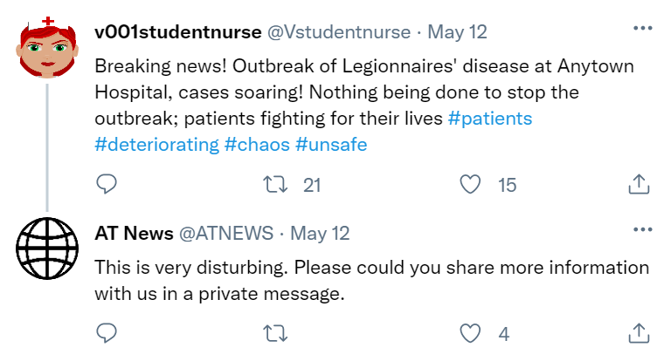

**MODULE 1: HOSPITAL**

INJECTS 2.0-2.2

**SESSION 2: QUESTIONS**

1. Has your risk assessment changed?
2. What are your next steps in the outbreak investigation and response?

What measures are you taking?

1. Who is communicating what to hospital staff, patients, the media, and the public? Who is leading on communication, and how you can ensure consistency of messaging?

**MODULE 1: HOSPITAL**

INJECT 3.0



**DATE:** 18 May  
**FROM:** Anytown Hospital   
**SUBJECT:** Legionnaires’ disease – death of two patients

**Report from Anytown Hospital**

Please note that the two inpatients previously diagnosed with Legionnaires’ disease have now died in hospital. The patients had been receiving treatment for leukaemia in the haematology-oncology ward. Given significant comorbidities in the patients, the cause of death is difficult to confirm.

No new *Legionella* infections have been detected in other patients treated on the same ward.

**Patient details:**

|  |  |  |  |  |  |  |
| --- | --- | --- | --- | --- | --- | --- |
| **ID** | **Sex** | **Age** | **Date of admission** | **Clinical status** | **Microbiology results** | **Date of test** |
| 1 | F | 54 | 22/04 | Deceased | UAT positive | 06/05 |
| 2 | M | 78 | 23/04 | Deceased | UAT positive | 06/05 |

**MODULE 1: HOSPITAL**

INJECT 3.1



**DATE:** 18 May  
**FROM:** AT News   
**SUBJECT:** Media enquiry – Legionnaires’ disease

**Media enquiry – time sensitive**

Good morning,

Please provide details of your spokesperson or media contact in charge of correspondence relating to the below incident:

We are looking to verify details around a **Legionnaire’s disease outbreak at Anytown Hospital**:

Please respond with details on the below queries or contact us to arrange a telephone interview to comment on the following:

* Confirmation of the deaths of two patients with Legionnaires’ disease at Anytown Hospital.
* Is the outbreak ongoing?
* Is there a risk involved to patients and staff and if so, what is being done to reduce further infections?
* Has a source been identified and is there any risk to local residents?

This information is requested urgently by 14:00 today. A news item is scheduled to be included in tomorrow’s AT News morning news programme.

Please contact the media desk by emailing [news@atnews.com](mailto:news@atnews.com).

**Anne Banks**

**Editor**

**AT News**

**MODULE 1: HOSPITAL**

INJECT 3.2



**DATE:** 19 May  
**FROM:** Anytown Hospital - Laboratory   
**SUBJECT:** Legionnaires’ disease; detailed microbiological

results

**Report from Anytown Hospital – Microbiological investigation results**

Good morning,

Please find below the testing results (culture; monoclonal antibody testing and sequence typing) for the clinical and environmental samples. Enumeration results are provided where available.

|  |  |  |  |
| --- | --- | --- | --- |
|  | **Culture** | **Monoclonal antibodies** | **Sequence type** |
| **Clinical samples** |  |  |  |
| Patient 1 | *Legionella pneumophila Sg1* | MAb-2 positive | ST36 |
| Patient 2 | *L. pneumophila Sg1* | MAb-2 positive | ST36 |
| **Environmental samples** |  |  |  |
| Sample 1 (Patient Room) | *L. pneumophila* detected  9.6x103 cfu/l | MAb-2 positive | ST36 |
| Sample 2 (Patient Room) | *L. pneumophila* detected  2.3x103 cfu/l | MAb-2 positive | ST36 |
| Sample 3 (Office) | Legionellae not isolated | | |
| Sample 4 (Patient Room) | *L. pneumophila* detected  1.9 x104 cfu/l | MAb-2 positive | ST36 |
| Sample 5 (Patient Room) | *L. pneumophila* detected | MAb-2 positive | ST36 |
| Sample 6 (Patient Room) | *L. pneumophila* detected | MAb-2 positive | ST36 |
| Sample 7 (Office) | *L. pneumophila* detected  1.5 x102 cfu/l | MAb-2 positive | ST36 |
| Sample 8 (Office) | *L. pneumophila* detected  1.1 x103 cfu/l | MAb-2 positive | ST36 |
| Sample 9 (Storage) | *L. pneumophila* detected  3.4 x 104 cfu/l | MAb-2 positive | ST36 |
| Sample 10 (Staff area) | *L. pneumophila* detected | MAb-2 positive | ST36 |

These results strongly implicate the hospital building’s drinking water system as the likely source of the outbreak. Kind regards, Anytown Hospital Laboratory

**MODULE 1: HOSPITAL**

INJECT 3.3



**DATE:** 19 May  
**FROM:** Ministry of Health   
**SUBJECT:** Legionnaires’ disease – after action review

**Outbreak of Legionnaires’ disease – after action review**

Good morning,

As the Anytown outbreak of Legionnaires’ disease has attracted considerable national news coverage, we are asking the local public health authority to convene an after action review with all parties involved in the outbreak investigation.

Please could you identify:

* Elements that went well
* Areas to improve and recommendations
* Measures to be taken to prevent such an outbreak in the future

Please send us your feedback by next week Wednesday, to prepare for a ministerial meeting on public health taking place on the Friday after.

Thank you,

**John Hardy**

Private Office

Minister of Health

**MODULE 1: HOSPITAL**

INJECTS 3.0-3.3

**SESSION 3: QUESTIONS**

1. What are your priorities for communication?
2. Has your public messaging changed in light of recent events? What messages are you now communicating to hospital staff, patients and the public, and how can you ensure consistency of messaging?
3. For your after-action review: From your organisation’s perspective, what went well and what didn’t go well in handling this outbreak? Please consider areas of water management, patient safety, communications, and others as appropriate.
4. What long-term prevention actions are being considered in view of lessons learned from this event?

**SESSION 1: QUESTIONS**