**MODULE 2: TRAVEL**

INJECT 1.0



**DATE:** 28 June  
**FROM:** ECDC via ELDSNet   
**SUBJECT:** Notification to Country A – Single case of

Legionnaires’ disease

**The following information has been sent to the ELDSNet contact point in your country:**

**Notification of a single case of Legionnaires’ disease**

ECDC has been informed of a confirmed case of Legionnaires’ disease in a **56-year-old female resident of Country B**, whose illness may be associated with travel to the following accommodation in your country:

**Clear River Inn Hotel, Anytown, Country A**

The reported date of onset was 15/06 and the patient has survived. Legionella infection was diagnosed by urinary antigen test.

The patient has reported a history of travel to:

* Clear River Inn Hotel, Anytown; Dates of stay: 1-8 June.

ECDC are not aware of any cases in the past two years at the above-named accommodation.

More information may be available from the reporter: **ELDSNet Contact Point Country B**

This notification does not imply that the accommodation named is the source of the infection.

**MODULE 2: TRAVEL**

INJECT 1.1



**DATE:** 28 June  
**FROM:** Anytown Hospital   
**SUBJECT:** Confirmed case of Legionnaires’ disease

**Report from Anytown Hospital**

Please find below the details of a confirmed case of Legionnaires’ disease at Anytown Hospital. The patient was admitted two days ago with severe symptoms of pneumonia.

The patient has tested positive for *Legionella pneumophila* today using a urinary antigen test. We have not yet been able to obtain a clinical sample for culture.

The patient is a resident of Anytown. No further information is available at this time.

**Patient details:**

|  |  |  |  |  |  |
| --- | --- | --- | --- | --- | --- |
| **Patient** | **Sex** | **Age** | **Date of admission** | **Clinical status** | **Microbiology results** |
| 1 | Male | 62 | 26 June | Severe symptoms of pneumonia | UAT positive on 28 June |

**MODULE 2: TRAVEL**

INJECT 1.2



**DATE:** 28 June  
**FROM:** Clear River Inn Hotel – Reservations   
**SUBJECT:** Hotel Information

**HOTEL INFORMATION – CLEAR RIVER INN HOTEL**

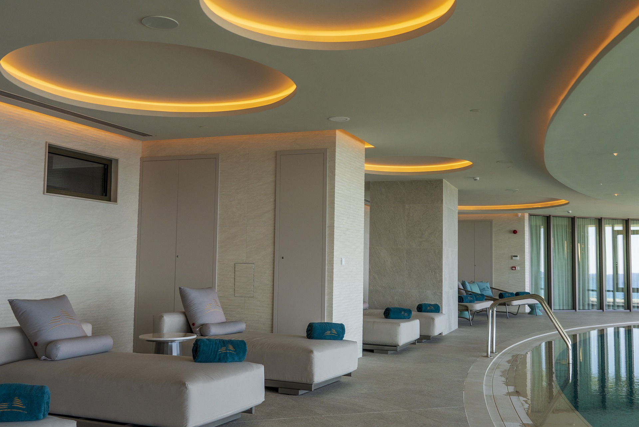

Clear River Inn Hotel in Anytown is located at the centre of the region’s business hub and features spacious meeting and events facilities.

We are hosting a large number of conferences every year, including academic conferences and corporate events.

Popular tourist destinations in the region are easily accessible.

The hotel is home to an award-winning spa and leisure centre.

**For further information and details on special offers:** [**www.clearriverinnhotelanytown.com**](http://www.clearriverinnhotelanytown.com)

**MODULE 2: TRAVEL**

INJECTS 1.0-1.2

**SESSION 1: QUESTIONS**

1. What is your initial risk assessment?
2. What immediate actions would you take at this point?

What are your next steps in the investigation of, and response to, this situation?

1. Who are you communicating with about this situation?

By which methods and to what timeline? What information do you need?

1. What are the co-ordination arrangements you should consider in this situation?

**MODULE 2: TRAVEL**

INJECT 2.0



**DATE:** 4 July, 10:00  
**FROM:** ECDC via ELDSNet   
**SUBJECT:** Cluster Alert – Clear River Inn Hotel, Anytown

**The following information has been sent to the ELDSNet contact point in your country:**

**Cluster Alert of Travel Associated Cases of Legionnaires’ Disease**

A total of two cases of Legionnaires’ disease have been reported to ELDSNet whose illness may be associated with a visit to: **Clear River Inn Hotel, Anytown**

**One additional case has been reported since our last notification on 28 June (in bold below):**

**Cluster C22/12345**

|  |  |  |  |  |  |  |  |
| --- | --- | --- | --- | --- | --- | --- | --- |
| Case ID | Sex | Age | Diagnostic Status | Date of Onset | Dates of Travel | Outcome | Reporter |
| CR1 | F | 56 | Confirmed | 15/06 | 01/06-08/06 | Alive | Country B |
| **CR2** | **F** | **42** | **Confirmed** | **14/06** | **01/06-07/06** | **Unknown** | **Country C** |

The newly reported case is a confirmed case in a 42-year-old woman, diagnosed by nucleic acid amplification, e.g. PCR, urinary antigen test.

More information may be available from the reporter: **ELDSNet Contact Point Country C**

This notification does not imply that the accommodation named is the source of the infection.

**MODULE 2: TRAVEL**

INJECT 2.1



**DATE:** 4 July, 17:00  
**FROM:** ECDC via ELDSNet   
**SUBJECT:** Cluster Alert – Lakeside View Resort, Anytown

**The following information has been sent to the ELDSNet contact point in your country:**

**Cluster Alert of Travel Associated Cases of Legionnaires’ Disease**

Two cases of Legionnaires’ disease have been reported to ELDSNet whose illness may be associated with a visit to: **Lakeside View Resort, Anytown**

**Cluster C22/12346**

|  |  |  |  |  |  |  |  |
| --- | --- | --- | --- | --- | --- | --- | --- |
| **Case ID** | **Sex** | **Age** | **Diagnostic Status** | **Date of Onset** | **Dates of Travel** | **Outcome** | **Reporter** |
| LVR1 | F | 55 | Confirmed | 18/06 | 03/06-10/06 | Unknown | Country C |
| LVR2 | M | 62 | Confirmed | 19/06 | 03/06-10/06 | Alive | Country D |

The two newly reported cases are a confirmed case in a 55-year-old woman, and another confirmed case in a 62-year-old male. Both were diagnosed by nucleic acid amplification e.g. PCR, and urinary antigen test.

More information may be available from the reporter: **ELDSNet Contact Point Country C, ELDSNet Contact Point Country D**

This notification does not imply that the accommodation named is the source of the infection.

**MODULE 2: TRAVEL**

INJECT 2.2



**DATE:** 4 July  
**FROM:** Lakeside View Resort – Reservations   
**SUBJECT:** Hotel Information

**Hotel information – Lakeside View Resort, Anytown**

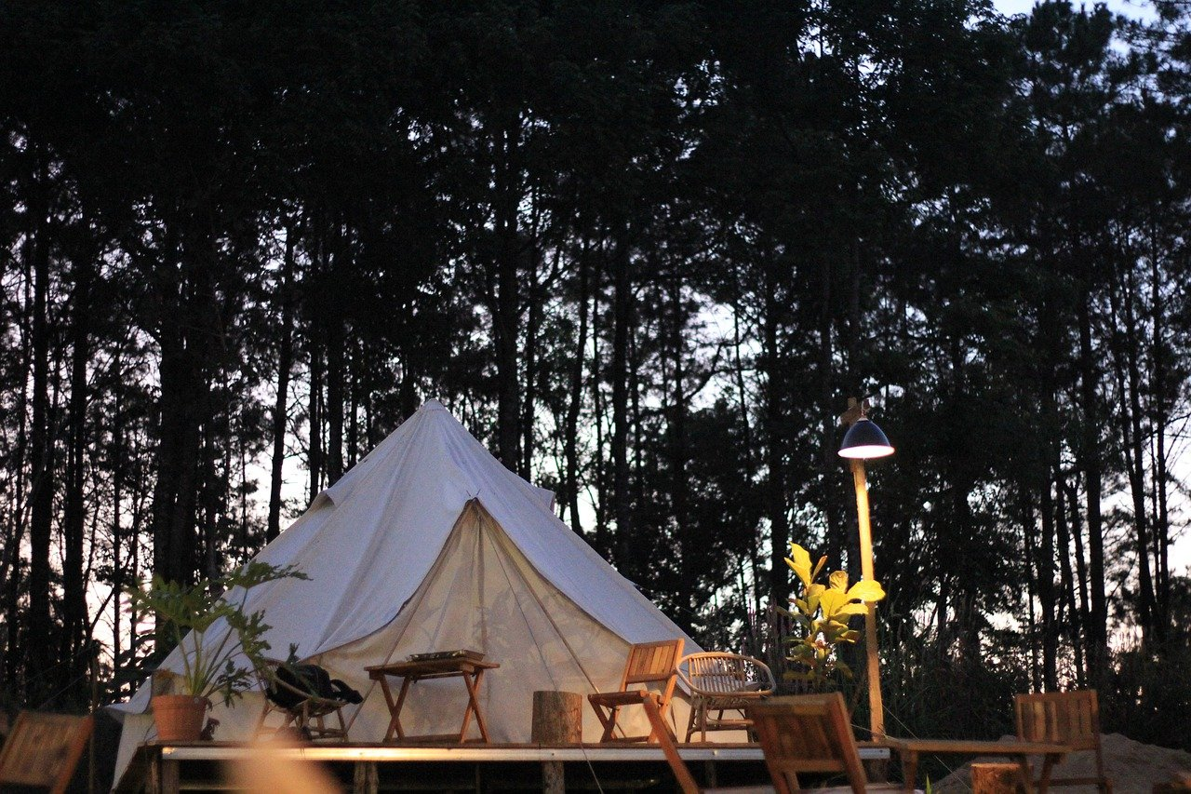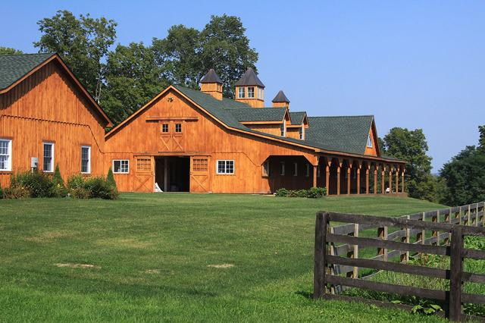

Lakeside View Resort offers glamping where guests stay in catered wooden huts and tents across a scenic campsite

Wooden hut glamping facilities include en-suite bathrooms and showers; excellent communal shower facilities available for those staying in tents

Campers have access to Anytown Lake and plenty of recreational activities and water sports

A business suite with desk space and state of the art conference facilities in a unique large communal wooden barn available to guests

Attractive to business visitors looking for a unique place to stay in Anytown or as a location to ‘work from home’ away from home

[**www.lakesideviewresortanytown.com**](http://www.lakesideviewresortanytown.com)

**MODULE 2: TRAVEL**

INJECT 2.3

**DATE & TIME:** 04 July  
 **FROM:** Anytown Hospital   
 **SUBJECT:** Additional info on confirmed case of   
 Legionellosis – Anytown Hospital



**DATE:** 4 July  
**FROM:** Anytown Hospital   
**SUBJECT:** Additional information on patients

**Report from Anytown Hospital**

Public health staff have concluded interviewing the patient suffering from Legionnaires’ disease at Anytown Hospital.

It has emerged that the man works as a catering manager at Clear River Inn Hotel in Anytown.

He furthermore reports that he has frequented the following sites in Anytown:

* The city centre
* Anytown Harbourside, the residential area where he lives
* A gym on the outskirts of town

We were able to obtain a sputum sample and have submitted this for culture testing in our laboratory.

**Patient details:**

|  |  |  |  |  |  |
| --- | --- | --- | --- | --- | --- |
| **Patient** | **Sex** | **Age** | **Date of admission** | **Clinical status** | **Microbiology results** |
| 1 | Male | 62 | 26 June | Severe symptoms of pneumonia | UAT positive on 28 June |

INJECT 2.4

**MODULE 2: TRAVEL**



**DATE:** 4 July  
**FROM:** Clear River Inn Hotel – Management   
**SUBJECT:** Results of recent water testing

**Results of water testing – Clear River Inn Hotel**

Good morning,

Please note that during our most recent water testing on 3 June, **no presence of Legionella was detected**. We are regularly testing our spa facilities and a number of water outlets in guest rooms.

We appreciate your health advice and agree to close our spa facilities for the time being, as a precautionary measure, and until results of further testing.

Please can we ask that this issue be kept confidential, so long as no presence of *Legionella* is proven at the hotel. We would like to prevent damage to our reputation and a loss of customers.

Kind regards,

**Melanie Gibb**

Management

Clear River Inn Hotel

**MODULE 2: TRAVEL**

INJECTS 2.0-2.4

**SESSION 2: QUESTIONS**

1. Has your risk assessment changed?
2. What are your next steps in the outbreak investigation and response?

What measures are you taking?

1. Who are you communicating what to the hotel, patients, the local public and international partners? Who is leading on this communication, and how can you ensure consistency of messaging?

INJECT 3.0

**MODULE 2: TRAVEL**



**DATE:** 6 July  
**FROM:** Environmental Health   
**SUBJECT:** Results of initial environmental investigation

**Environmental investigation results – Clear River Inn Hotel**

Good afternoon,

Please see the following update on the environmental investigation:

* Results from environmental water samples taken at the hotel on 4 July indicate qPCR positive results for *Legionella pneumophila* in a large decorative fountain situated at the entrance to the conferencing floor.
* However, samples taken from the spa pools, guest rooms and offices did not indicate presence of *Legionella pneumophila* through qPCR.
* All samples have been submitted for culture, the results of which are still pending.
* Hotel management advised that the fountain has been out of operation as the conference facilities were not used much during the holiday season. It had only recently been activated again, and therefore no water samples were taken during the hotel’s last routine Legionella inspection.

**Noora Kinnunen**

Environmental Health Officer

Anytown City Council

**MODULE 2: TRAVEL**

INJECT 3.1



**DATE:** 10 July  
**FROM:** ECDC via ELDSNet   
**SUBJECT:** Cluster update C22/12345

**The following information has been sent to the ELDSNet contact point in your country:**

**Cluster Update of Travel Associated Cases of Legionnaires’ Disease (Page 1 of 2)**A total of eight cases of Legionnaires’ disease have been reported to ELDSNet whose illness may be associated with a visit to: **Clear River Inn Hotel, Anytown.**

**Six new cases were reported since the last notification on 4 July (in bold below). This is now a rapidly evolving cluster.**  
**Cluster C22/12345**

|  |  |  |  |  |  |  |  |
| --- | --- | --- | --- | --- | --- | --- | --- |
| **Case ID** | **Sex** | **Age** | **Diagnostic Status** | **Date of Onset** | **Dates of Travel** | **Outcome** | **Reporter** |
| CR1 | F | 56 | Confirmed | 15/06 | 01/06-08/06 | Died | Country B |
| CR2 | F | 42 | Confirmed | 14/06 | 01/06-08/06 | Unknown | Country C |
| **CR3** | **M** | **35** | **Probable** | **16/06** | **01/06-07/06** | **Unknown** | **Country C** |
| **CR4** | **M** | **73** | **Confirmed** | **20/06** | **05/06-10/06** | **Alive** | **Country D** |
| **CR5** | **F** | **78** | **Confirmed** | **21/06** | **10/06-12/06** | **Alive** | **Country D** |
| **CR6** | **F** | **45** | **Confirmed** | **21/06** | **10/06-12/06** | **Alive** | **Country D** |
| **CR7** | **M** | **62** | **Confirmed** | **18/06** | **09/06-12/06** | **Alive** | **Country E** |
| **CR8** | **M** | **44** | **Probable** | **20/06** | **09/06-12/06** | **Alive** | **Country E** |

*Continued on second page.*

**MODULE 2: TRAVEL**

INJECT 3.1 continued

**Cluster Update of Travel Associated Cases of Legionnaires’ Disease (Page 2 of2)**

The most recently reported cases are:

* a probable case in a 35-year-old male, diagnosed by nucleic acid amplification, e.g. PCR
* a confirmed case in a 73-year-old male, diagnosed by urinary antigen test
* a confirmed case in a 78-year-old female, diagnosed by urinary antigen test
* a confirmed case in a 45-year-old female, diagnosed by urinary antigen test
* a confirmed case in a 62-year-old male, diagnosed by urinary antigen test
* a probable case in a 44-year-old male, diagnosed by nucleic acid amplification, e.g. PCR

Additional information on Cases ID CR1 and CR2 has also been provided by Country B and Country C upon request:

* Results from sputum cultures available for both cases report isolation of *Legionella pneumophila* serogroup 1, sequence type ST47
* Beyond the accommodation indicated above, both cases report having visited Anytown city centre and the train station. Both cases attended a conference with ca. 50 other people at the Clear River Inn Hotel on 5-8 June.

More information may be available from the ELDSNet reporters.

**MODULE 2: TRAVEL**

INJECT 3.2



**DATE:** 10 July  
**FROM:** Anytown Sunshine Tours   
**SUBJECT:** URGENT public health advice required

**Message from Anytown Sunshine Tours**

Good morning,

My name is Sarah Jordan from Anytown Sunshine Tours. We are a large regional coach tour operator in Anytown and the surrounding areas. Please could you provide us with public health advice in relation to a customer falling ill on a recent tour to Anytown.

The customer, who is a foreign citizen, has reported that he and several friends who were also on the tour have fallen ill about a week after their tour with us; he is complaining of flu-like symptoms.

We seek your expert advice on whether the customer’s claim that the coach air conditioning was the cause is plausible. We have taken all required health and safety measures according to legislation.

**Tour details**

**Date:** 23 June **Visited:** Anytown city centre and townhall, Anytown Cathedral, spa facilities at Clear River Inn Hotel and a gala dinner at the same hotel’s conference facilities.

If you need any further information, please do get in touch and we look forward to your advice on the matter.

Kind regards,

**Sarah Jordan**

Director

Anytown Sunshine Tours

INJECT 3.3

**MODULE 2: TRAVEL**



**DATE:** 10 July  
**FROM:** AT News   
**SUBJECT:** Media enquiry – Legionnaires’ disease

**Media enquiry – time sensitive**

Please provide details of your spokesperson or media contact in charge of correspondence relating to the below incident:

We are looking to verify details around a possible **Legionnaire’s disease outbreak** in Anytown.

Please respond with details on the below queries or contact us to arrange a telephone interview:

* Can you confirm there is an outbreak of Legionnaires’ disease, and is it still ongoing?
* What is the risk to local residents and what is being done to prevent further infections?
* Has a source been identified?
* Is there any connection to the recent closure of the popular Clear River Inn Hotel spa facilities for maintenance?

This information is requested urgently by 14:00 today. A news items is scheduled to be included in tomorrow’s AT News morning news programme.

Please contact the media desk by emailing [news@atnews.com](mailto:news@atnews.com)

**Jim Hughes**

Assistant Editor

AT News

**MODULE 2: TRAVEL**

INJECT 3.4



**DATE:** 10 July  
**FROM:** Lakeside View Resort Management   
**SUBJECT:** Water testing results – Lakeside View Resort

**Results of water testing – Lakeside View Resort**

Good afternoon,

The laboratory has just confirmed that PCR results from water and environmental samples taken at Lakeside View Resort on 6 July indicate no presence of *Legionella* in any of the samples collected.

Samples were collected in the communal showers, all showers and taps in guest rooms and staff facilities.

We hope this clears up the matter and if you require any further information, please do get in touch.

Thanks for your support and assistance on this matter.

**Aaron King**

Hotel Manager

Lakeside View Resort - Anytown

**MODULE 2: TRAVEL**

INJECT 3.5



**DATE:** 10 July  
**FROM:** Anytown Laboratory   
**SUBJECT:** Environmental investigation Clear River Inn Hotel

**Environmental investigation results – Clear River Inn Hotel**

Good afternoon,

Please find below the results of culture testing of environmental samples taken at Clear River Inn Hotel on 4 July:

* Samples analysed were taken from spa pools, guest rooms, offices and a decorative fountain at Clear River Inn Hotel.
* The sample from the decorative fountain has come back positive for Legionella pneumophila serogroup 1, sequence type ST47.
* All other samples were negative for presence of Legionella.

Kind regards,

Anytown Laboratory

INJECT 3.6

**MODULE 2: TRAVEL**



**DATE:** 10 July  
**FROM:** ECDC via ELDSNet   
**SUBJECT:** Updated information – Cluster C22/12346

**The following information has been sent to the ELDSNet contact point in your country:**

**Cluster Update of Travel Associated Cases of Legionnaires’ Disease**Further information has been shared on Cluster **C22/12346** upon request, relating to accommodation at: **Lakeside View Resort, Anytown**

|  |  |  |  |  |  |  |  |
| --- | --- | --- | --- | --- | --- | --- | --- |
| **Case ID** | **Sex** | **Age** | **Diagnostic Status** | **Date of Onset** | **Dates of Travel** | **Outcome** | **Reporter** |
| LVR1 | F | 55 | Confirmed | 18/06 | 03/06-10/06 | Hospitalised | Country C |
| LVR2 | M | 62 | Confirmed | 19/06 | 03/06-10/06 | Discharged | Country D |

**Case ID LVR1**: This patient is currently hospitalised. She has travelled to Anytown for tourism purposes and to attend a conference at Clear River Inn Hotel on 8 June. She has also visited Anytown city centre and tourist destinations across the wider region.

**Case ID LVR2**: The patient has been discharged from hospital after having recovered from Legionnaires’ disease. The patient reports having visited Anytown together with his partner for a business conference on 5 June. The conference took place at Clear River Inn Hotel. The patient reports also visiting Anytown city centre and the local shopping mall.

**MODULE 2: TRAVEL**

INJECT 3.0-3.6

**SESSION 3: QUESTIONS**

1. What are your next steps in the outbreak investigation and response?
2. What are your priorities for communication?

How are you communicating with international partners (e.g. reporting countries, ELDSNet), and what reporting requirements do you have to adhere to?

1. Has your public messaging changed?

What messages are you now communicating to the hotel, patients, the media and the public, and international partners, and how can you ensure consistency of messaging?

1. What long-term prevention actions are being considered in view of lessons learned from this event?