**MODULE 3: COMMUNITY**

INJECT 1.0



**DATE:** 4 August  
**FROM:** Anytown Hospital   
**SUBJECT:** Patients with Legionnaires’ disease

**Notification of 8 patients with Legionnaires’ disease from Anytown hospital**

Please find below the details of 8 patients with confirmed or suspected Legionnaires’ disease, among inpatients at Anytown Hospital, all of whom are residents of Anytown. Diagnoses between 31 July and 3 August.

|  |  |  |  |  |  |  |  |
| --- | --- | --- | --- | --- | --- | --- | --- |
| **ID** | **Sex** | **Age** | **Symptom onset** | **Admission** | **Clinical status** | **Microbiology results** | **Date of test** |
| 1 | M | 45 | 23/07 | 31/07 | Suspected pneumonia, chest pain, cough | UAT* pos for Lp sg 1** | 31/07 (primary health doctor) |
| 2 | F | 72 | 26/07 | 29/07 | Pneumonia, nausea, vomiting, and diarrhoea; high fever, cough | UAT pos for Lp sg 1 | 03/08 |
| 3 | M | 54 | 27/07 | 30/07 | Pneumonia, fever, cough | UAT pos for Lp sg 1 | 03/08 |
| 4 | M | 55 | 27/07 | 30/07 | Pneumonia, fever, cough, difficulty breathing | UAT pos for Lp sg 1 | 03/08 |
| 5 | M | 62 | 30/07 | 31/07 | Suspected pneumonia, high fever, cough, difficulty breathing | UAT pos for Lp sg 1 | 03/08 |
| 6 | F | 89 | 30/07 | 31/07 | Disorientation, confusion, gastrointestinal discomfort | UAT pos for Lp sg 1 | 03/08 |
| 7 | F | 78 | 30/07 | 01/08 | Suspected pneumonia, fever, cough | UAT pos for Lp sg 1 | 03/08 |
| 8 | M | 66 | 30/07 | 01/08 | Pneumonia, high fever, breathlessness; deteriorating. Immunocompromised due to cancer, chemotherapy. | UAT pos for Lp sg 1 | 03/08 |

*\* Urinary Antigen Test*

*\*\*Legionella pneumophila serogroup 1*

Note: A mean of 19.4 cases per year (range 16–26) were recorded in Anytown over the past five years. Until 1 August, 6 cases of Legionnaires’ disease have been reported in Anytown this year.

**MODULE 3: COMMUNITY**

INJECT 1.0

**SESSION 1: QUESTIONS**

1. What is your initial assessment?
   1. Is this an outbreak? Why or why not?
   2. Discuss use of case definitions.
2. What immediate actions would you take at this point?   
   What are your next steps in the investigation of, and response to, this situation?
3. Who are you communicating with about this situation?   
   By which methods and to what timeline? What information do you need?
4. What are the co-ordination arrangements you should consider in this situation?

INJECT 2.0

**MODULE 3: COMMUNITY**



**DATE:** 7 August  
**FROM:** Anytown Hospital   
**SUBJECT:** Additional cases of Legionnaires’ disease

**Notification of 12 additional cases of Legionnaires’ disease from Anytown hospital**

Please note the following additional 12 patients now diagnosed with Legionnaires’ disease since our previous report on 4 August.

|  |  |  |  |  |  |  |  |
| --- | --- | --- | --- | --- | --- | --- | --- |
| **ID** | **Sex** | **Age** | **Symptom onset** | **Admission** | **Clinical status** | **Microbiology results** | **Date of test** |
| 9 | M | 55 | 31/07 | 04/08 | Pneumonia, fever, cough | UAT pos for Lp sg 1 | 04/08 |
| 10 | M | 76 | 31/07 | 05/08 | Pneumonia, fever, cough | UAT pos for Lp sg 1 | 05/08 |
| 11 | M | 46 | 01/08 | 05/08 | Pneumonia, fever, cough, difficulty breathing | UAT pos for Lp sg1 | 05/08 |
| 12 | F | 79 | 01/08 | 05/08 | Pneumonia, fever, cough | UAT pos for Lp sg 1 | 06/08 |
| 13 | M | 88 | 01/08 | 06/08 | Pneumonia, nausea, vomiting, and diarrhoea; high fever | UAT pos for Lp sg 1 | 06/08 |
| 14 | F | 92 | 02/08 | 06/08 | Pneumonia, disorientation, confusion, gastrointestinal discomfort | UAT pos for Lp sg 1 | 06/08 |
| 15 | F | 56 | 02/08 | 06/08 | Pneumonia, fever, cough | UAT pos for Lp sg 1 | 06/08 |
| 16 | M | 63 | 02/08 | 07/08 | Pneumonia, high fever, cough;  Immunocompromised due to cancer, chemotherapy. | UAT pos for Lp sg 1 | 07/08 |
| 17 | M | 63 | 03/08 | 07/08 | Pneumonia, fever, cough | UAT pos for Lp sg 1 | 07/08 |
| 18 | M | 78 | 03/08 | 07/08 | Pneumonia, chest pain, cough | UAT pos for Lp sg 1 | 07/08 |
| 19 | M | 47 | 03/08 | 07/08 | Pneumonia, high fever, cough;  Immunocompromised due to cancer, chemotherapy. | UAT pos for Lp sg 1 | 07/08 |
| 20 | M | 49 | 03/08 | 07/08 | Pneumonia, chest pain, cough | UAT pos for Lp sg 1 | 07/08 |

Please also note that five of the eight original patients reported on 4 August have now been admitted to the Intensive Care Unit. All eight also have a diagnosis of clinical pneumonia.

INJECT 2.1

**MODULE 3: COMMUNITY**



**DATE:** 7 August  
**FROM:** Public Health Officer   
**SUBJECT:** Case finding

**Results from case finding and review of previous Legionnaires’ disease notifications in the Anytown area**

A review of previous notifications of patients with Legionellosis from 1 May, as well as active case finding in Anytown and the areas neighbouring Anytown, allowed the identification of 33 Legionnaires’ disease cases in total so far. In addition to the cases notified by Anytown Hospital on 4 and 7 August, the review lists the following cases (all having clinical diagnosis of pneumonia), not all of which are necessarily linked to the current outbreak:

|  |  |  |  |  |  |  |
| --- | --- | --- | --- | --- | --- | --- |
| **ID** | **Sex** | **Age** | **Symptom onset** | **Microbiology results** | **Date of test** | **Notes** |
| 21 | F | 78 | 24/06 | UAT pos for Lp sg 1 | 29/06 | Potential sporadic case, no particular risk sources identified |
| 22 | M | 67 | 27/06 | UAT pos for Lp sg 1 | 03/07 | Potential nosocomial case, due to incubation time spent in medical rehabilitation facility |
| 23 | M | 65 | 03/07 | UAT pos for Lp sg 1 | 10/07 | Potential travel-associated to Country B, due to travel abroad for two weeks before falling ill |
| 24 | M | 65 | 11/07 | UAT pos for Lp sg 1 | 19/07 | Diagnosed by primary health doctor, recovered |
| 25 | F | 72 | 11/07 | UAT pos for Lp sg 1 | 19/07 | Diagnosed by primary health doctor, recovered |
| 26 | F | 48 | 15/07 | UAT pos for Lp sg 1 | 20/07 | Diagnosed by primary health doctor, recovered |
| 27 | M | 95 | 18/07 | UAT pos for Lp sg 1 | 24/07 | Diagnosed by primary health doctor, deceased |
| 28 | F | 77 | 21/07 | UAT pos for Lp sg 1 | 27/07 | Diagnosed in Neighbourtown Hospital, recovered and discharged |
| 29 | M | 69 | 21/07 | UAT pos for Lp sg 1 | 27/07 | Diagnosed in Neighbourtown Hospital, recovered and discharged |
| 30 | M | 77 | 22/07 | UAT pos for Lp sg 1 | 31/07 | Patient hospitalised in Neighbourtown |
| 31 | M | 59 | 22/07 | UAT pos for Lp sg 1 | 31/07 | Patient hospitalised in Neighbourtown |
| 32 | M | 82 | 23/07 | UAT pos for Lp sg 1 | 31/07 | Patient hospitalised in Neighbourtown |
| 33 | F | 81 | 24/07 | UAT pos for Lp sg 1 | 31/07 | Patient hospitalised in Neighbourtown |

*Continued on second page.*



**DATE:** 7 August  
**FROM:** Public Health Officer   
**SUBJECT:** Case finding

**Results from case finding and review of previous Legionnaires’ disease notifications in the Anytown area**

Please see below a chart plotting all 33 cases by date of symptom onset:

Please note that all cases are Anytown residents. Case interviews are currently taking place.

INJECT 2.1 continued

**MODULE 3: COMMUNITY**

INJECT 2.2

**MODULE 3: COMMUNITY**



**DATE:** 8 August  
**FROM:** National Meteorological Service   
**SUBJECT:** Meteorological data Anytown, 1 June to 31 July

**Evaluation of local weather conditions for Anytown, 1 June to 31 July**

Good morning,

The evaluation of the meteorological conditions from Anytown showed that the mean temperatures were on average 3.2 and 1.2°C above the climatological mean (1981–2020) during June and July, respectively, in association with stormy conditions in late June and early July.

A heat wave was recorded in the Anytown area from 6 to 13 July, with the third highest mean temperature recorded since 1864.

A gusty, northerly wind coincided with the days of the heat wave; a rare weather phenomenon for Anytown, where the usual wind direction is from the southwest.

Please let us know if you have any further questions.

**Hannah Lange**

Administrative Officer

National Meteorological Service

INJECT 2.3

**MODULE 3: COMMUNITY**



**DATE:** 8 August  
**FROM:** Public Health Officer   
**SUBJECT:** Case geographical mapping

**Geographical mapping of confirmed Legionnaires’ disease cases across Anytown**

Case interviews identified overlapping visit, work or residential locations, including local movements, pointing to the Anytown Harbour area for 25/33 cases, comprising 13 residents, 2 workers and 10 visitors (people visiting cafés, restaurants, shops or having regular activities in the area for more than two hours per day)

Mapping of confirmed cases of Legionnaires’ disease in Anytown by place of residence provides the following picture. Blue dots indicate 25 confirmed cases with a connection to the Anytown Harbour area. Red dots indicate 8 confirmed cases with no such connection.

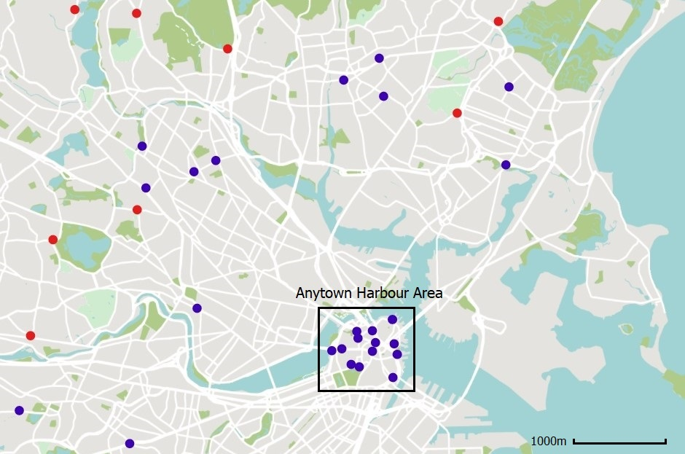

**MODULE 3: COMMUNITY**

INJECT 2.4



**DATE:** 8 August  
**FROM:** Anytown City Council   
**SUBJECT:** Register of cooling tower systems in Anytown

**Register of at-risk cooling tower systems in Anytown**

Good afternoon,

Anytown City Council holds a voluntary register of cooling tower systems at risk of *Legionella*. There are four sites with 6 wet cooling towers in the central Anytown area noted in this register which concern residential large tower blocks and two manufacturing industries.

Please note that the register has not been actively updated for the last four years as the city’s resources for public health have been cut following the last council elections.

I hope this is helpful to your investigations.

Kind regards,

**Thomas Jenner**

Senior Executive Officer

Anytown City Council

**MODULE 3: COMMUNITY**

INJECT 2.5



**DATE:** 9 August  
**FROM:** Public Health Officer   
**SUBJECT:** Aerosol dispersion model

**Aerosol dispersion model with potential sources' plumes**

Modelling of aerosol dispersion for the cooling towers identified by Anytown City Council for the period of 1 June to 7 August provides the following map.

The four triangles reflect the four cooling tower sites in the area (A, B, C, D). Aerosol dispersion is indicated as high, medium and low, according to the intensity of colour used.

Note that the model reflects the varying wind conditions during the observation period (blowing from the north between 5-11 July, and from south-west for the remaining days between 1 June to 7 August).



A

B

C

D

INJECTS 2.0-2.5

**MODULE 3: COMMUNITY**

**SESSION 2: QUESTIONS**

1. What does your risk assessment look like?
2. What can you learn from the epidemic curve?
   1. What is the minimum, median maximum incubation time? Plot the minimum incubation time on the first case, the median on the peak and the maximum on the case with latest onset.
   2. What is the most likely time of transmission? Does it look like a point source or is transmission still ongoing?
3. What are your next steps in the outbreak investigation and response?   
   What measures are you taking?
4. Are you communicating with the public and the media?   
   What key messages and formats are being considered?

**MODULE 3: COMMUNITY**

INJECT 3.0



**DATE:** 16 August  
**FROM:** Anytown Laboratory   
**SUBJECT:** Results of environmental samples

**DATE & TIME:** 06 July, 10:00  
 **FROM:** Environmental Agency - Anytown   
 **SUBJECT:** Environmental investigation results – Clear River   
 Inn Hotel

**Results of samples taken from cooling towers in central Anytown area**

Please find below the test results of environmental samples taken from cooling towers in the central Anytown area:

|  |  |  |  |
| --- | --- | --- | --- |
| **Site** | **Legionella detected** | **Highest sample cfu/l** | **Type** |
| A | No |  | n/a |
| B | Yes | 1.5×106 | L. pneumophila serogroup 1 ST23, mAb France-Allentown |
| C | No |  | n/a |
| D | Yes | 3×103 | L. pneumophila serogroup 1 ST23 mAb France-Allentown;  ST1 OLDA/Oxford |

* Environmental samples were taken in 6 cooling towers at four sites in the Anytown area (A, B, C, D). The sampled cultures of two cooling towers revealed concentrations of L. pneumophila above the recommended national threshold for which resampling, maintenance and disinfection procedures should occur.
* Monoclonal antibodies and sequence-based typing of several colonies isolated from these positive environmental samples revealed the presence of L. pneumophila serogroup 1 ST23 mAb France-Allentown in site B, and of L. pneumophila serogroup 1 ST23 mAb France-Allentown and ST1 mAb OLDA/Oxford in site D.
* No Legionella was identified in sites A and C.

**MODULE 3: COMMUNITY**

INJECT 3.1



**DATE:** 16 August  
**FROM:** Anytown Hospital Laboratory   
**SUBJECT:** Sequence results of clinical samples

**Results of clinical samples taken from patients at Anytown Hospital**

Monoclonal antibodies and sequence-based typing analyses were performed on 14 clinical samples. These analyses allowed the complete subtype identification for 10 samples:

* L. pneumophila serogroup 1 ST62 mAb Knoxville: 6 samples
* L. pneumophila serogroup 1 ST23 mAB France-Allentown: 3 samples
* L. pneumophila serogroup 1 ST1 mAb OLDA/Oxford: 1 sample

All patients infected with L. pneumophila serogroup 1 ST62 had an exposure to Anytown Harbour area. Two patients infected with L. pneumophila serogroup 1 ST23 also had an exposure to Anytown Harbour area.

**ST1**



A

B

C

D

**ST23**

**ST62**

**ST62**

**ST23**

**ST62**

**ST62**

**ST23**

**ST62**

**ST62**

INJECT 3.2

**MODULE 3: COMMUNITY**



**DATE:** 16 August  
**FROM:** Anytown Gazette   
**SUBJECT:** Media enquiry

**Urgent! Request for information on Anytown Legionella Outbreak**

Good morning,

Please could you provide information on the following questions in relation to an alleged outbreak of Legionnaire’s disease in Anytown:

* How many cases have you identified so far?
* How many people have died? We have heard that at least two patients at Anytown Hospital have died as a result of the infection.
* Can you confirm whether the Anytown Harbour area presents a risk to locals?
* What advice can you give local residents on how to protect themselves?

You can see below that Anytown residents are already reporting their concerns on social media:

Please provide a response by 14:00 today: [health@anytowngazette.com](mailto:health@anytowngazette.com)

**Torben Clark**

Journalist, Anytown Gazette

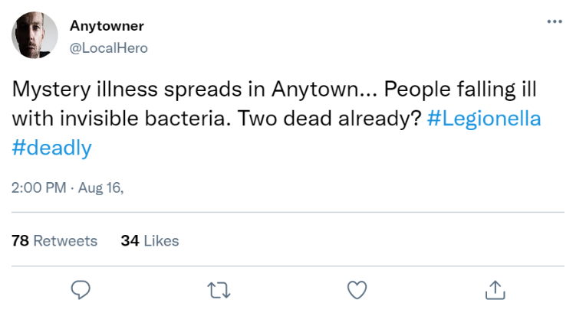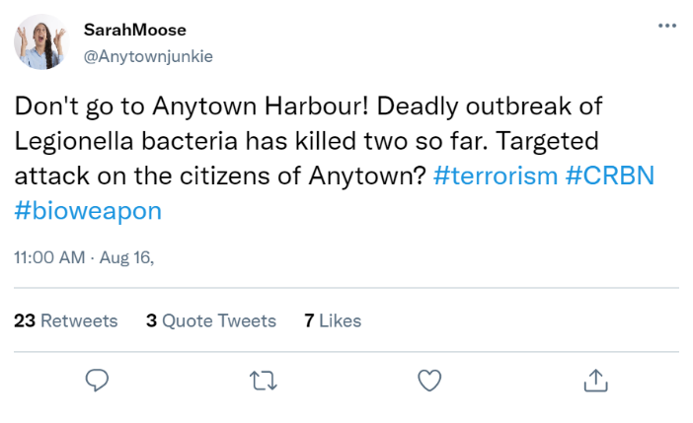

**MODULE 3: COMMUNITY**

INJECT 3.3



**DATE:** 16 August  
**FROM:** Occupational Health – Port of Anytown   
**SUBJECT:** Public health advice

**Enquiry from Occupational Health Department at Port of Anytown**

Good afternoon,

I work as a nurse at Port of Anytown’s Occupational Health Department. I am contacting you to find out more information about the source of the Legionella outbreak in Anytown, and the associated dangers for port workers.

Two of our staff members have so far been hospitalised with Legionnaires’ disease, and several other port workers are now starting to exhibit flu-like symptoms.

I am also concerned about rising absenteeism, as our staff members are increasingly worried about catching an infectious disease.

Could you please provide me with your expert advice on what to tell our workers about the outbreak and associated risks. Please also advise how to manage those staff falling ill.

Thank you,

**Steve Jones**

Occupational Health Nurse

Port of Anytown

**MODULE 3: COMMUNITY**

INJECT 3.4



**DATE:** 16 August  
**FROM:** Environmental Health – Anytown City Council   
**SUBJECT:** New information on possible outbreak sources

**New information on possible outbreak sources**

Good afternoon,

Further to our previous correspondence, we have discovered some new information about a possible source of the current Legionnaires’ disease outbreak.

It seems that due to the recent redevelopment of existing buildings in the harbour area to accommodate luxury apartments, a cooling tower which had been out of use in the recent year has been reactivated recently (late June) to service some of these new apartments.

Testing of water samples from the cooling tower basins is ongoing but dispersal plume mapping would suggest a plausible source based on exposure area (site E).

I hope this helps with your outbreak investigation.



A

B

C

D

E

INJECTS 3.0-3.4

**MODULE 3: COMMUNITY**

**SESSION 3: QUESTIONS**

1. What are your next steps in the outbreak investigation and response?
2. How do you interpret the environmental and clinical sample results?   
   What factors may explain the inconclusive results?
3. What are your priorities for communication?   
   What information are you giving to the media, national partners and the public?
4. What long-term prevention actions are being considered in view of lessons learned from this event?