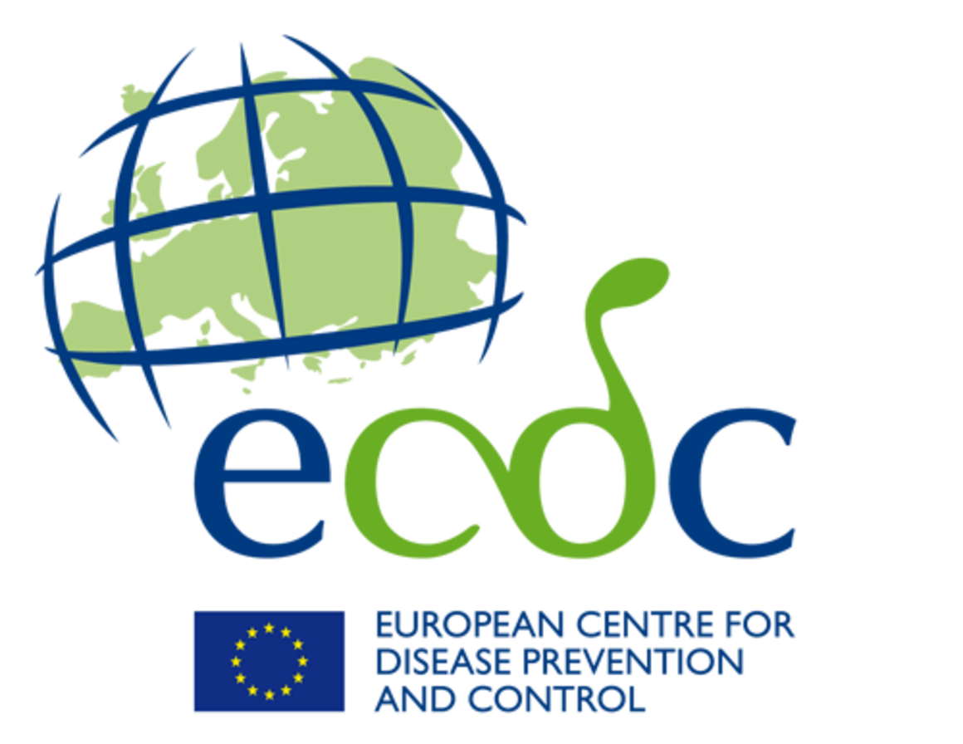
Exercise Philadelphia
Participant Response Form – Module 3: Community
To help ensure that all actions and responses are accurately captured, will you please nominate a chair and a notetaker for your group. The chair’s role is to guide your exercise discussions and they will be asked provide feedback in the plenary sessions. The notetaker should capture your actions and responses in this document. The information captured in these workbooks will be used to inform the final exercise report.
INJECT 1.0
MODULE 3: COMMUNITY
SESSION 1: QUESTIONS
- What is your initial assessment? Is this an outbreak? Why or why not? Discuss use of case definitions.

- What immediate actions would you take at this point? What are your next steps in the investigation of, and response to, this situation?
- Who are you communicating with about this situation? By which methods and to what timeline? What information do you need?
- What are the co-ordination arrangements you should consider in this situation?

INJECTS 2.0-2.5
MODULE 3: COMMUNITY
SESSION 2: QUESTIONS

- What does your risk assessment look like?
- What can you learn from the epidemic curve?
What is the minimum, median maximum incubation time? Plot the minimum incubation time on the first case, the median on the peak and the maximum on the case with latest onset.
What is the most likely time of transmission? Does it look like a point source or is transmission still ongoing?

- What are your next steps in the outbreak investigation and response? What measures are you taking?
- Are you communicating with the public and the media? What key messages and formats are being considered?

INJECTS 3.0-3.4
MODULE 3: COMMUNITY
SESSION 3: QUESTIONS
- What are your next steps in the outbreak investigation and response?
- How do you interpret the environmental and clinical sample results? What factors may explain the inconclusive results?

- What are your priorities for communication? What information are you giving to the media, national partners and the public?

- What long-term prevention actions are being considered in view of lessons learned from this event?

